Year 9 Mathematics Curriculum Medium-Term Plan HT3

.

The most important purpose of curriculum planning documents is that they will specify everything that students should learn. What is not specified is far less likely to be taught, let alone assessed appropriately.

Term | Half Term | Year 9 Overview
Autumn | HT1 | LO1: Place Value  LO2: Ordering decimals & Integers.  LO3: Calculations with negative numbers.  LO4: BIDMAS  LO5: Powers & Roots & Primes and proof  LO6: Standard Form
 | HT2 | LO1: Algebraic expressions.  LO2: Solving Equations  LO3: Writing formulas  LO4: Position to term rule.
Spring | HT3 | LO1: Equivalent fractions  LO2: Adding and subtracting Fractions  L03: Mixed numbers & Improper fractions.  LO4: Multiplying whole numbers by fractions.  LO5: Simplifying Ratio.  LO6: Percentage Change.
 | HT4 | LO1: Properties of triangles & Quadrilaterals.  LO2: Deduction  LO3: Rotation and Translation  LO4: Vectors
Summer | HT5 | LO1: Probability Scale.  LO2: Sample space diagram.  LO3: Venn Diagrams.  LO4: Transformations.  LO5: Three dimensional shape.  LO6: Pythagoras
 | HT 6 | LO1: Scatter graphs & Correlation.  LO2: Lines of best fit  LO3: Mean, median, mode & Ranges.  LO4: Ungrouped& Grouped frequency tables.  LO5: Pictograms & Bar Charts.  LO6: Construction

Term & Year Group | Spring Term 3
Links to the National Curriculum/Examination Specification | - Select and use appropriate calculation strategies to solve increasingly complex problems;  - Move freely between different numerical, algebraic, graphical and diagrammatic representations [for example, equivalent fractions, fractions and decimals, and equations and graphs];  - Use language and properties precisely to analyse numbers, algebraic expressions, 2-D and 3-D shapes, probability and statistics;  - Extend their understanding of the number system; make connections between number relationships, and their algebraic and graphical representations;  - Extend and formalise their knowledge of ratio and proportion in working with measures and geometry, and in formulating proportional relations algebraically;  - Make and test conjectures about patterns and relationships; look for proofs or counter- examples;  - Begin to reason deductively in geometry, number and algebra, including using geometrical constructions;  - Interpret when the structure of a numerical problem requires additive, multiplicative or proportional reasoning;  - Order positive and negative integers, decimals and fractions; use the number line as a model for ordering of the real numbers; use the symbols =, ≠, <, >, ≤, ≥;  - Use the four operations, including formal written methods, applied to integers, decimals, proper and improper fractions, and mixed numbers, all both positive and negative; Recognise and use relationships between operations including inverse operations;  - Work interchangeably with terminating decimals and their corresponding fractions;  - Define percentage as ‘number of parts per hundred’, interpret percentages and percentage changes as a fraction or a decimal, interpret these multiplicatively, express one quantity as a percentage of another, compare two quantities using percentages, and work with percentages greater than 100%;  - Interpret fractions and percentages as operators;  - Use a calculator and other technologies to calculate results accurately and then interpret them appropriately;  - Change freely between related standard units [for example time, length, area, volume/capacity, mass];  - Use scale factors, scale diagrams and maps;  - Express one quantity as a fraction of another, where the fraction is less than 1 and greater than 1;  - Use ratio notation, including reduction to simplest form; Divide a given quantity into two parts in a given part:part or part:whole ratio;  - Express the division of a quantity into two parts as a ratio;  - Understand that a multiplicative relationship between two quantities can be expressed as a ratio or a fraction;  - Relate the language of ratios and the associated calculations to the arithmetic of fractions and to linear functions;  - Solve problems involving percentage change, including: percentage increase, decrease and original value problems and simple interest in financial mathematics;  - Solve problems involving direct and inverse proportion, including graphical and algebraic representations; use compound units such as speed, unit pricing and density to solve problems  - Develop their mathematical knowledge, in part through solving problems and evaluating the outcomes, including multi-step problems;  - Develop their use of formal mathematical knowledge to interpret and solve problems, including in financial mathematics;  - Begin to model situations mathematically and express the results using a range of formal mathematical representations;  - Select appropriate concepts, methods and techniques to apply to unfamiliar and non- routine problems.
Overall Aims | What are the overarching aims for students in terms of the key substantive knowledge components, disciplinary knowledge (skills) and understanding they will develop?  By the end of this unit students should have greater fluency with working with fractions, ratio and percentages. The main knowledge is:  - Re-writing fractions with a common denominator  - Equivalent fractions  - Simplifying fractions  - Ordering fractions  - Adding and subtracting fractions with the same denominator  - Adding and subtracting fractions with different denominators  - Problem solving involving fraction addition and subtraction and ordering fractions  - Converting improper fractions to mixed numbers and vice versa  - Fraction multiplication  - Fractions of a quantity  - Fraction division using KFC  - Problem solving with fractions involving all 4 operations  - Writing a problem as a ratio  - Simplifying ratio  - Ratios and fractions  - Problem solving ratio questions  - Dividing ratios  - Calculating % of a quantity (mental methods and calculator)  - % reductions eg sale prices (mental methods and calculator)  - % increases – mental methods  - Calculator methods for % changes
Prior learning & common misconceptions | What learning has come before this unit that should be drawn upon to secure deeper understanding and make connections?  Students need to understand the concept as a fraction as part of a whole and be confident with describing fractions.  What are the common misconceptions that hinder progress?  When students add or subtract fractions they add/subtract the denominators as well. They need to be able to convert to equivalent fractions with the same denominator before embarking on addition/subtraction where denominators are different.  Students will need lots of visuals to help them compare, convert or calculate with fractions before removing the visual. When students get stuck return to using visuals.  Students need to understand that fractions, decimals, percentages and ratio are all really the same concept but looked at in different contexts.
Assessment | How will student progress be assessed through both formative & summative assessments?  Lesson by Lesson  Use of mini-whiteboards  Low stakes quizzes for connect activities to embed prior learning – especially with mathematical terminology  Daily opportunities for retrieval practice in recall activity at beginning of lesson  Pupils will be regularly assessed through classwork, features of this include routine starter tasks that allow a revisit to previously taught aspects of the curriculum to improve recall;  Progress Checks  Low stake quizzes eg Bingo  Skillful Q&A by teachers is a regular feature of maths lessons to assess understanding, inform activities, and identify any misconceptions.  Individual feedback provided to students identifying next steps  End of Topic  Half termly assessments, with QLA produced (not yet at KS3), used formatively to inform recall tasks  Individual feedback provided to students identifying next steps
Language & Reading | What is the provision to…  Talk like a specialist  - Students will be introduced to key terminology and be challenged to use this at every opportunity  Write like a specialist.  - Include reason and examples in answers and write algebraically and graphically  Read like a specialist  - Given a written problem, interpret and use information to navigate an efficient pathway that results in an accurate solution  - Read and interpret mathematics written algebraically or graphically
Links to SMSC/SRE/British Values | Spiritual Education  - We strive to enable each of our students to use their imagination and creativity to explore ideas while learning mathematics by: identifying and applying patterns and rules to everyday problem-solving;  - Writing their own problems and challenges that use those patterns or rules.  Moral Education  - Broadening the pupils' understanding of the consequences of actions: Eg. If you perform a particular action to one number, will the same outcome apply to other numbers? Is it always the case? ‘Sometimes, always, never’ statements will be explored and addressed.  Social Education Developing personal qualities and using social skills:  - Working in pairs or groups to solve problems; Perseverance when struggling to answer questions; not being afraid to try – it’s ok to be wrong, it’s not ok not to try; taking turns when playing maths games. Participating, co-operating and resolving conflicts: as above, but also ‘X thinks ___, Y thinks ___, who is right?’ type questions.  Cultural Education  - Understanding and appreciating personal influences: taking into account other people’s views and understanding how to express own views. Eg. How to explain to someone where they may have gone wrong in a question.  British Values  Democracy  - Take into account the views of others in shared activities. Voting when collecting data.  The Rule of Law  - Undertake safe practices, following class rules during tasks and activities for the benefit of all. Understand the consequences if rules are not followed.  Individual Liberty  - Work within boundaries to make safe choices during practical activities. Make your own choices within data handling activities.  Tolerance of those with different faiths and beliefs  - Use maths to learn about different faiths and cultures around the world. Eg. looking at patterns/shapes within Islam / Hindu religions.  Mutual Respect  - To behave appropriately, allowing all participants the opportunity to work effectively. Take turns and share equipment. Review each other’s work respectfully. Work collaboratively on projects/problems, help and advise others

Knowledge Components at a Glance

Composite Performance: Fluency with Number

I know how to find a percentage change or an amount after a percentage change.
I know how to find the original value of an item before a percentage change.
I know how to calculate simple interest.
I know how ratio links to fractions

Percentages
Fractions
Ratio
I can find a percentage change or an amount after a percentage change.
I can find the original value of an item before a percentage change.
I can use simple interest.

I know what equivalent fractions are.
I know the rules of addition and subtraction of fractions
I know that mixed numbers and improper fractions are the same fraction written in different ways.
I know the rules of multiplying and dividing fractions

I can simplify ratios and use ratios to solve problems.

I can identify equivalent fractions, simplify fractions, rewrite fractions over a common denominator and put fractions in order of size.
I can apply the rules of addition and subtraction of fractions
I can convert between mixed numbers add improper fractions.
I can add and subtract two mixed numbers.
I can apply the rules of multiplying and dividing fractions

I can read a worded question and decide whether I am calculating a percentage increase or decrease.

I can decide when it is better to write a mixed number as an improper fraction

Week/ Lesson  Key Question? | Key knowledge components & Lesson Outcomes  What do students need to know & what should they be able to do? | Pedagogy & Assessment– How do we teach and assess this at Coal Clough Academy? Strategies to support students knowing more & remembering more  Suggested teaching activities & resources including ‘non-negotiables’ for delivery e.g. minimum of two assessment style questions per week, minimum of one practical per week…
Week 1/ Lesson 1 | What are the key knowledge components students must be taught this lesson?  - I know what equivalent fractions are.  - I can identify equivalent fractions, simplify fractions, rewrite fractions over a common denominator and put fractions in order of size.  What are the learning outcomes for this lesson?  - Re-writing fractions with a common denominator  - Equivalent fractions  Key Questions:  Using the fraction wall, tell me a fraction equivalent to $\frac{1}{3}$?  How many fractions can you find equivalent to $\frac{1}{2}$?  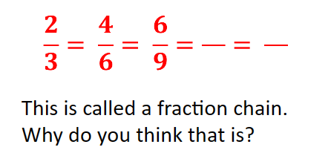  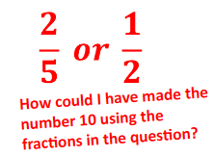 | Key vocabulary for this lesson & how it will be introduced?  Equivalent, numerator, denominator, ascending, descending  Recall activity: 4 Qs (last lesson, last week, last month, last topic); Use questions from assessments (informal and formal) and QLA.  Suggested teaching activities, pedagogy and assessment to inform next steps:  Start with a fraction wall so that students can see combinations of equivalent fractions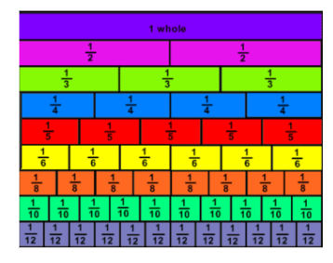  Once students are secure with the concept of equivalence take away the fraction wall and teach them how to write equivalent fractions numerically, starting with fraction chains (see example in Key Questions)  Initially students may need help identifying the common denominator (see example in key questions)  Then move to comparing 2 fractions by writing with a common denominator eg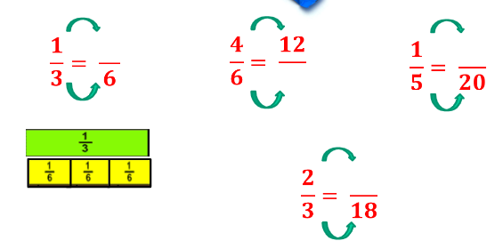
Addressing gaps  SEND learners have a Pupil Passport that informs strategies for learning bespoke to that student.  Staff must make sure they are familiar with the various strategies involved and embed these in their lessons.  If students don’t understand any concepts return to using visuals. Only remove the visuals when you are confident they are secure. |  | Deepening knowledge  Give some questions for students to compare a fraction with a percentage/decimal such as:  Which is bigger 75% or $\frac{16}{20}$ ?  Give more than 2 fractions for students to order eg:  Put these fractions in ascending order  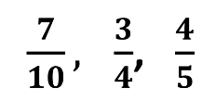

Week/ Lesson  Key Question? | Key knowledge components & Lesson Outcomes  What do students need to know & what should they be able to do? | Pedagogy & Assessment– How do we teach and assess this at Coal Clough Academy? Strategies to support students knowing more & remembering more  Suggested teaching activities & resources including ‘non-negotiables’ for delivery e.g. minimum of two assessment style questions per week, minimum of one practical per week…
Week 1/ Lesson 2 | What are the key knowledge components students must be taught this lesson?  - I can identify equivalent fractions, simplify fractions, rewrite fractions over a common denominator and put fractions in order of size.  What are the learning outcomes for this lesson?  - Simplifying fractions  Key Questions:  $$\frac{5}{12}$$  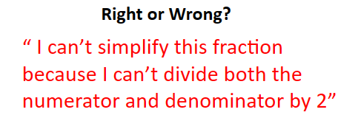  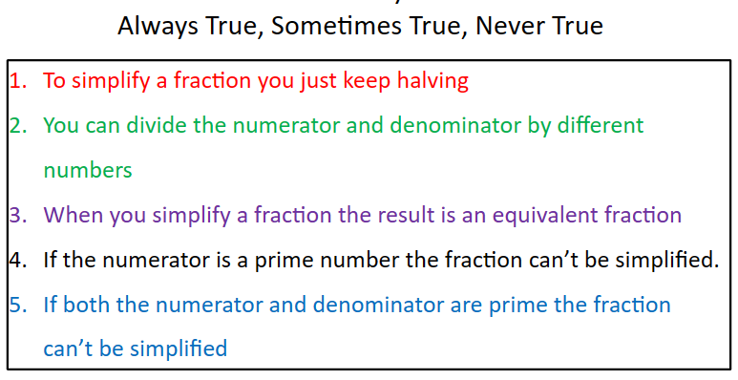  How do I know when I have fully simplified a fraction? | Key vocabulary for this lesson & how it will be introduced?  Equivalent, numerator, denominator, ascending, descending, simplify, cancel-down  Recall activity: 4 Qs (last lesson, last week, last month, last topic); Use questions from assessments (informal and formal) and QLA.  Suggested teaching activities, pedagogy and assessment to inform next steps:  Start where students are simplifying by dividing by 2/halving each time  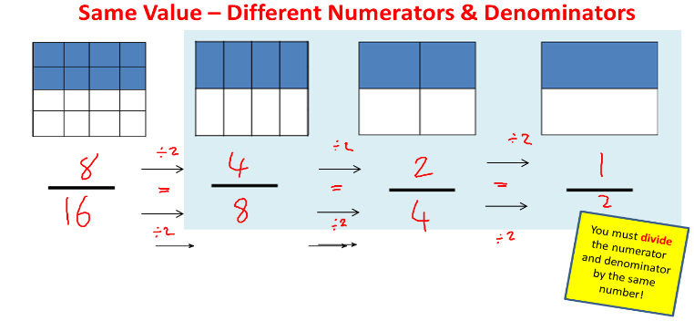  Move to examples where to simplify you need to divide by numbers other than 2 eg  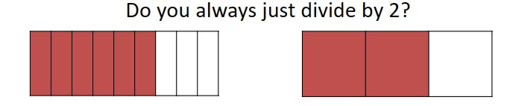  Then give students a generalization to help them simplify any given fraction:  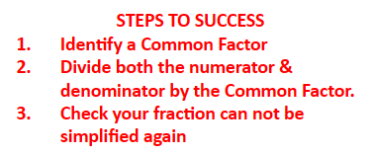  Check they are secure and then give examples top consolidate.  Finish with probing questions to help them generalize (See Always/Sometimes/Never True questions under ‘key questions’)
Addressing gaps  SEND learners have a Pupil Passport that informs strategies for learning bespoke to that student.  Staff must make sure they are familiar with the various strategies involved and embed these in their lessons. |  | Deepening knowledge  Give questions where students have to simplify first and then order a list of fractions.

Week/ Lesson  Key Question? | Key knowledge components & Lesson Outcomes  What do students need to know & what should they be able to do? | Pedagogy & Assessment– How do we teach and assess this at Coal Clough Academy? Strategies to support students knowing more & remembering more  Suggested teaching activities & resources including ‘non-negotiables’ for delivery e.g. minimum of two assessment style questions per week, minimum of one practical per week…
Week 1/ Lesson 3 | What are the key knowledge components students must be taught this lesson?  - I can identify equivalent fractions, simplify fractions, rewrite fractions over a common denominator and put fractions in order of size.  What are the learning outcomes for this lesson?  - Ordering fractions  Key Questions:  Is this statement true or false? Why?  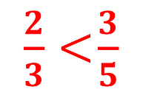 | Key vocabulary for this lesson & how it will be introduced?  Equivalent, numerator, denominator, ascending, descending, simplify, cancel-down  Recall activity: 4 Qs (last lesson, last week, last month, last topic); Use questions from assessments (informal and formal) and QLA.  Suggested teaching activities, pedagogy and assessment to inform next steps:  Recap on equivalent fractions and comparing 2 fractions.   Give students list of fractions to put in ascending or descending order.  Recap on simplifying fractions.  Give students lists of fractions that need to be simplified before ordered. This is consolidation of the previous 2 lessons.
Addressing gaps  SEND learners have a Pupil Passport that informs strategies for learning bespoke to that student.  Staff must make sure they are familiar with the various strategies involved and embed these in their lessons.  Whenever a student gets stuck return to using visuals of fractions until they understand and then remove the visual. |  | Deepening knowledge  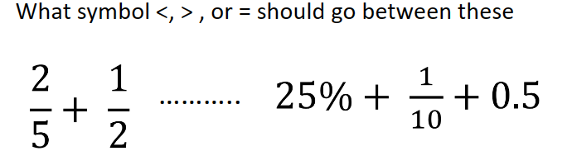

Week/ Lesson  Key Question? | Key knowledge components & Lesson Outcomes  What do students need to know & what should they be able to do? | Pedagogy & Assessment– How do we teach and assess this at Coal Clough Academy? Strategies to support students knowing more & remembering more  Suggested teaching activities & resources including ‘non-negotiables’ for delivery e.g. minimum of two assessment style questions per week, minimum of one practical per week…
Week 2/ Lesson 1 | What are the key knowledge components students must be taught this lesson?  - I know the rules of addition and subtraction of fractions  - I can apply the rules of addition and subtraction of fractions  What are the learning outcomes for this lesson?  - Adding and subtracting fractions with the same denominator  - Adding and subtracting fractions with different denominators  Key Questions:  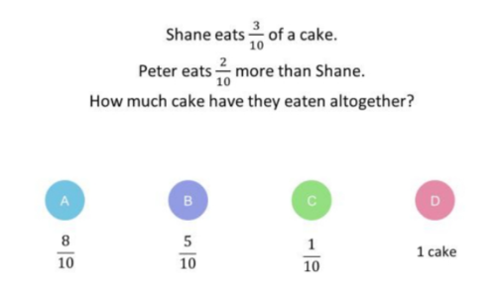  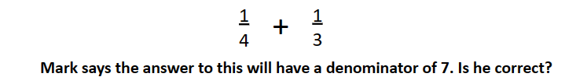  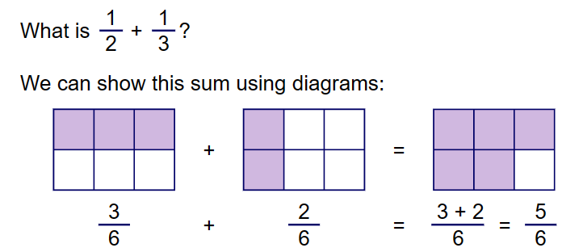 | Key vocabulary for this lesson & how it will be introduced?  Equivalent, numerator, denominator, ascending, descending, simplify, cancel-down,  Recall activity: 4 Qs (last lesson, last week, last month, last topic); Use questions from assessments (informal and formal) and QLA.  Suggested teaching activities, pedagogy and assessment to inform next steps:  Start by adding/subtracting fractions with the same denominators. 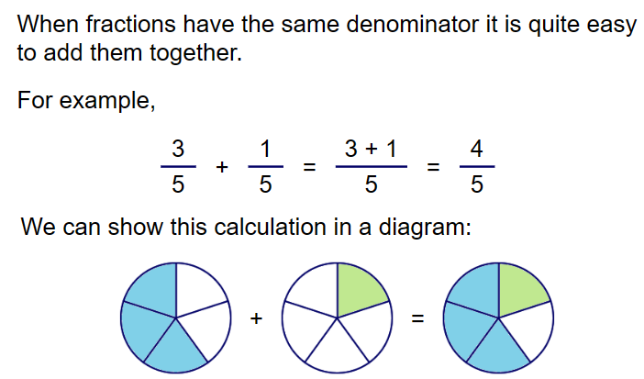  Once secure with fractions with the same denominator introduce different denominators so that they need to incorporate equivalent fractions.  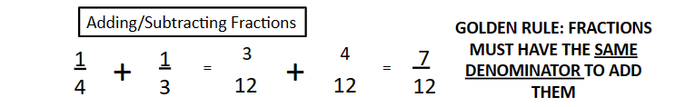  Once students can add/subtract fractions with different denominators give them non-routine questions such as whole numbers.  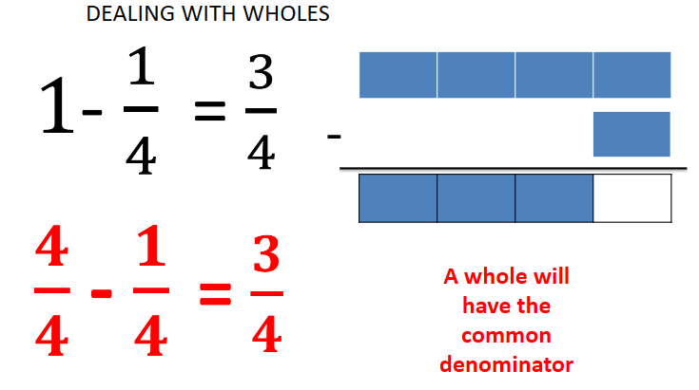
Addressing gaps  SEND learners have a Pupil Passport that informs strategies for learning bespoke to that student.  Staff must make sure they are familiar with the various strategies involved and embed these in their lessons.  Students often forget that you can only add/subtract fractions with the same denominators. They also add both the numerators and denominators. Ask questions that expose this misconception.  Return to using visuals any time a student doesn’t understand. |  | Deepening knowledge  Give examples with mixed fractions  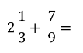  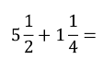  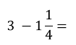

Week/ Lesson  Key Question? | Key knowledge components & Lesson Outcomes  What do students need to know & what should they be able to do? | Pedagogy & Assessment– How do we teach and assess this at Coal Clough Academy? Strategies to support students knowing more & remembering more  Suggested teaching activities & resources including ‘non-negotiables’ for delivery e.g. minimum of two assessment style questions per week, minimum of one practical per week…
Week 2/ Lesson 2 | What are the key knowledge components students must be taught this lesson?  - I can apply the rules of addition and subtraction of fractions  - I can identify equivalent fractions, simplify fractions, rewrite fractions over a common denominator and put fractions in order of size.  What are the learning outcomes for this lesson?  - Problem solving involving fraction addition and subtraction and ordering fractions  Key Questions:  See questions from lessons in last 2 weeks. | Key vocabulary for this lesson & how it will be introduced?  Equivalent, numerator, denominator, ascending, descending, simplify, cancel-down,  Recall activity: 4 Qs (last lesson, last week, last month, last topic); Use questions from assessments (informal and formal) and QLA.  Suggested teaching activities, pedagogy and assessment to inform next steps:  This lesson is applying the skills learned in the previous fraction lessons through problem solving and other mathematical strands. Use questions as in the examples below:  Find the perimeter of these shapes  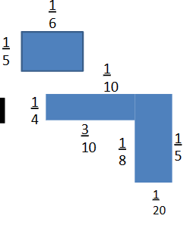  Based on the class progress you may wish to recap some of the concepts from the last 2 weeks beforehand.  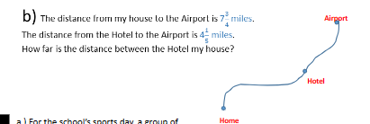  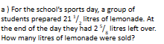
Addressing gaps  SEND learners have a Pupil Passport that informs strategies for learning bespoke to that student.  Staff must make sure they are familiar with the various strategies involved and embed these in their lessons. |  | Deepening knowledge

Week/ Lesson  Key Question? | Key knowledge components & Lesson Outcomes  What do students need to know & what should they be able to do? | Pedagogy & Assessment– How do we teach and assess this at Coal Clough Academy? Strategies to support students knowing more & remembering more  Suggested teaching activities & resources including ‘non-negotiables’ for delivery e.g. minimum of two assessment style questions per week, minimum of one practical per week…
Week 2/ Lesson 3 | What are the key knowledge components students must be taught this lesson?  - I know that mixed numbers and improper fractions are the same fraction written in different ways.  - I can convert between mixed numbers add improper fractions.  What are the learning outcomes for this lesson?  - Converting improper fractions to mixed numbers and vice versa  Key Questions:  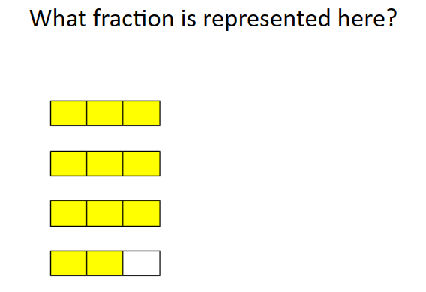  When would we want to write a fraction as an improper fraction?  When is it better to write a fraction as a mixed number? | Key vocabulary for this lesson & how it will be introduced?  Equivalent, numerator, denominator, ascending, descending, simplify, cancel-down, improper fraction, mixed number  Recall activity: 4 Qs (last lesson, last week, last month, last topic); Use questions from assessments (informal and formal) and QLA.  Suggested teaching activities, pedagogy and assessment to inform next steps:  Start by using diagrams to teach students understand how to convert mixed numbers to improper fractions.  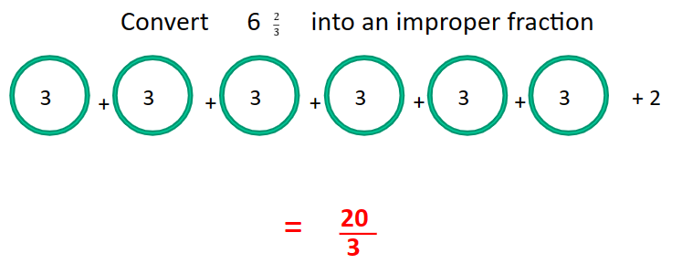  Likewise for converting improper fractions to mixed numbers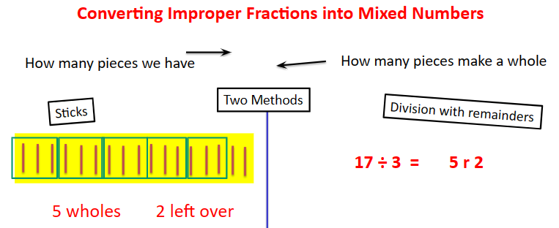
Addressing gaps  SEND learners have a Pupil Passport that informs strategies for learning bespoke to that student.  Staff must make sure they are familiar with the various strategies involved and embed these in their lessons.  Be explicit that improper fraction and its equivalent mixed number are the same amount but sometimes it’s easier to calculate in one format versus the other. |  | Deepening knowledge  Give problem solving questions involving improper fractions and mixed numbers  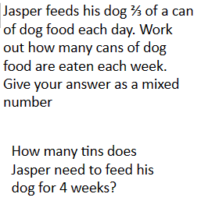

Week/ Lesson  Key Question? | Key knowledge components & Lesson Outcomes  What do students need to know & what should they be able to do? | Pedagogy & Assessment– How do we teach and assess this at Coal Clough Academy? Strategies to support students knowing more & remembering more  Suggested teaching activities & resources including ‘non-negotiables’ for delivery e.g. minimum of two assessment style questions per week, minimum of one practical per week…
Week 3/ Lesson 1 | What are the key knowledge components students must be taught this lesson?  - I know the rules of multiplying and dividing fractions  - I can apply the rules of multiplying and dividing fractions  What are the learning outcomes for this lesson?  - Fraction multiplication  - Fractions of a quantity  Key Questions:  How do I multiply these 2 fractions?  What would I do if I had 3 fractions to multiply together?  How could I make this calculation easier?  $\frac{15}{20}$ x $\frac{2}{10}$  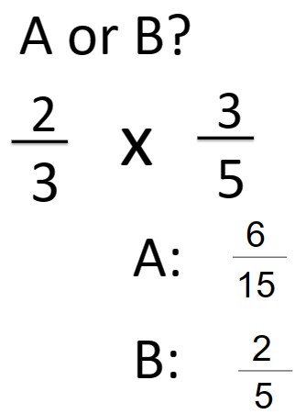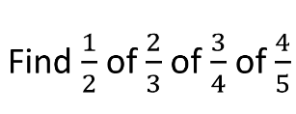 | Key vocabulary for this lesson & how it will be introduced?  Equivalent, numerator, denominator, ascending, descending, simplify, cancel-down, improper fraction, mixed number  Recall activity: 4 Qs (last lesson, last week, last month, last topic); Use questions from assessments (informal and formal) and QLA.  Suggested teaching activities, pedagogy and assessment to inform next steps:  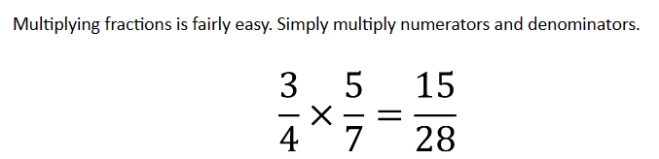  Give them examples where they should simplify before multiplying eg  $\frac{15}{20}$ x $\frac{2}{10}$  Once students are secure with fraction multiplication start to look at fractions of quantities eg $\frac{1}{3}$ x 12. Use unitary fractions only initially. Be explicit that $\frac{1}{3}$ x 12 is the same as $\frac{1}{3}$ of 12  Move onto non-unitary fractions teaching them to find the unit fraction first and then multiply. For example, for $\frac{4}{5}$ x 20, calculate $\frac{1}{5}$ x 20 first and then multiply the answer by 4.
Addressing gaps  SEND learners have a Pupil Passport that informs strategies for learning bespoke to that student.  Staff must make sure they are familiar with the various strategies involved and embed these in their lessons.  Be explicit with students that when you are asked to find a fraction OF a quantity ‘of’ means multiply. |  | Deepening knowledge  Give examples involving mixed numbers  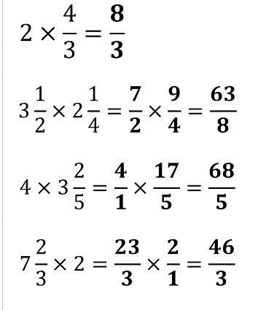  Give examples involving negatives eg $\frac{2}{3}$ x -6

Week/ Lesson  Key Question? | Key knowledge components & Lesson Outcomes  What do students need to know & what should they be able to do? | Pedagogy & Assessment– How do we teach and assess this at Coal Clough Academy? Strategies to support students knowing more & remembering more  Suggested teaching activities & resources including ‘non-negotiables’ for delivery e.g. minimum of two assessment style questions per week, minimum of one practical per week…
Week 3/ Lesson 2 | What are the key knowledge components students must be taught this lesson?  - I know the rules of multiplying and dividing fractions  - I can apply the rules of multiplying and dividing fractions  What are the learning outcomes for this lesson?  - Fraction division using KFC  Key Questions:  What do we mean by the word reciprocate? When we reciprocate a fraction, what do we do to it?  Dividing by 2 is the same as multiplying by what fraction?  Dividing by 3 is the same as multiplying by what fraction?  Dividing by x is the same as multiplying by what fraction? | Key vocabulary for this lesson & how it will be introduced?  Equivalent, numerator, denominator, ascending, descending, simplify, cancel-down, improper fraction, mixed number, reciprocate  Recall activity: 4 Qs (last lesson, last week, last month, last topic); Use questions from assessments (informal and formal) and QLA.  Suggested teaching activities, pedagogy and assessment to inform next steps:  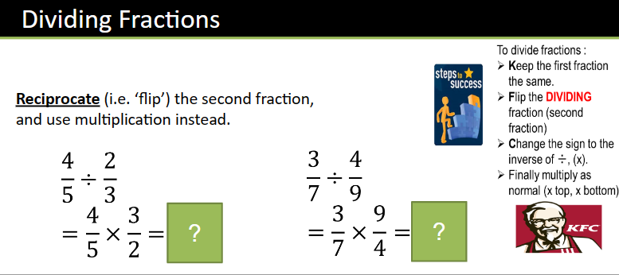  Give students examples to consolidate  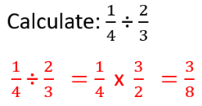  Once they can follow the method give harder examples where they have to simplify before calculating as well as examples with mixed numbers and improper fractions
Addressing gaps  SEND learners have a Pupil Passport that informs strategies for learning bespoke to that student.  Staff must make sure they are familiar with the various strategies involved and embed these in their lessons. |  | Deepening knowledge  Give examples from another mathematical strand eg  Find the missing side  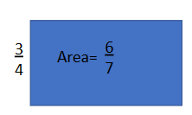  Give problem solving examples  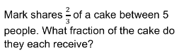

Week/ Lesson  Key Question? | Key knowledge components & Lesson Outcomes  What do students need to know & what should they be able to do? | Pedagogy & Assessment– How do we teach and assess this at Coal Clough Academy? Strategies to support students knowing more & remembering more  Suggested teaching activities & resources including ‘non-negotiables’ for delivery e.g. minimum of two assessment style questions per week, minimum of one practical per week…
Week 3/ Lesson 3 | What are the key knowledge components students must be taught this lesson?  - I can add and subtract two mixed numbers.  - I can decide when it is better to write a mixed number as an improper fraction  What are the learning outcomes for this lesson?  - Problem solving with fractions involving all 4 operations  Key Questions: | Key vocabulary for this lesson & how it will be introduced?  Equivalent, numerator, denominator, ascending, descending, simplify, cancel-down, improper fraction, mixed number, reciprocate  Recall activity: 4 Qs (last lesson, last week, last month, last topic); Use questions from assessments (informal and formal) and QLA.  Suggested teaching activities, pedagogy and assessment to inform next steps:  This is a consolidation lesson. Give students as many questions to do with problem solving or from other strands of maths. See examples from last 3 weeks. You may need to re-cap some of the concepts before they solve problems.
Addressing gaps  SEND learners have a Pupil Passport that informs strategies for learning bespoke to that student.  Staff must make sure they are familiar with the various strategies involved and embed these in their lessons. |  | Deepening knowledge  Mix questions involving fractions, decimals and percentages.

Week/ Lesson  Key Question? | Key knowledge components & Lesson Outcomes  What do students need to know & what should they be able to do? | Pedagogy & Assessment– How do we teach and assess this at Coal Clough Academy? Strategies to support students knowing more & remembering more  Suggested teaching activities & resources including ‘non-negotiables’ for delivery e.g. minimum of two assessment style questions per week, minimum of one practical per week…
Week 4/ Lesson 1 | What are the key knowledge components students must be taught this lesson?  - I know how ratio links to fractions  - I can simplify ratios and use ratios to solve problems.  What are the learning outcomes for this lesson?  Writing a problem as a ratio  - Simplifying ratio  Key Questions:  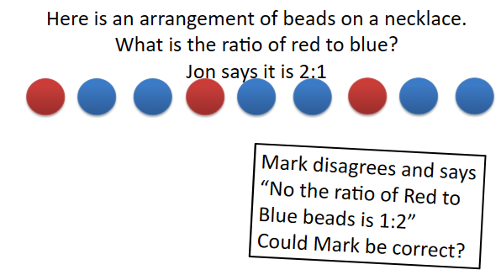 | Key vocabulary for this lesson & how it will be introduced?  Ratio, part, simplest form, proportion  Recall activity: 4 Qs (last lesson, last week, last month, last topic); Use questions from assessments (informal and formal) and QLA.  Suggested teaching activities, pedagogy and assessment to inform next steps:  Start by establishing how we write a ratio – see the first key question. Students need to understand that the numbers of the ratio go in the same order as the words. For example red to blue is 1:2, whereas blue to red is 2:1. The language is important. Give examples where all students need to do is read a problem and write it as a ratio.  Then move to simplifying a ratio  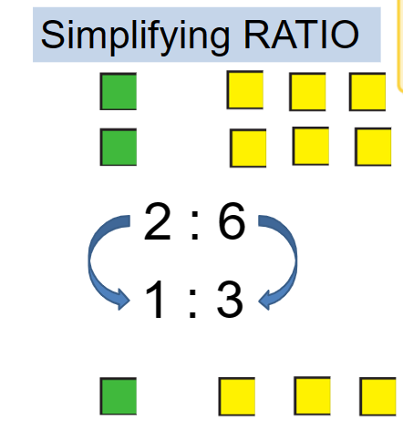  Start with visuals and then move to simplifying ratios without the visual  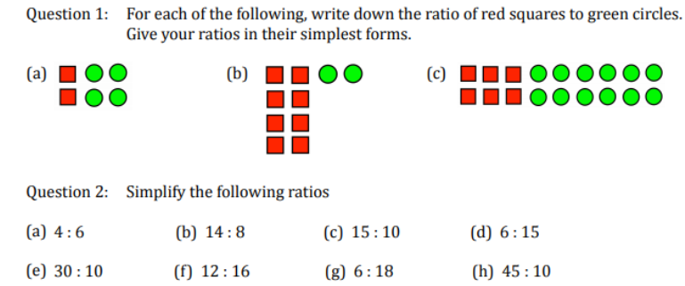
Addressing gaps  SEND learners have a Pupil Passport that informs strategies for learning bespoke to that student.  Staff must make sure they are familiar with the various strategies involved and embed these in their lessons.  Whenever a student does not understand revert to diagrams to help explain ratio questions. Encourage them to draw diagrams to help themselves answer questions. |  | Deepening knowledge  Give problem solving questions eg.,  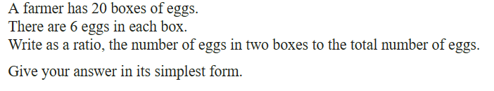

Week/ Lesson  Key Question? | Key knowledge components & Lesson Outcomes  What do students need to know & what should they be able to do? | Pedagogy & Assessment– How do we teach and assess this at Coal Clough Academy? Strategies to support students knowing more & remembering more  Suggested teaching activities & resources including ‘non-negotiables’ for delivery e.g. minimum of two assessment style questions per week, minimum of one practical per week…
Week 4/ Lesson 2 | What are the key knowledge components students must be taught this lesson?  - I know how ratio links to fractions  - I can simplify ratios and use ratios to solve problems.  What are the learning outcomes for this lesson?  - Ratios and fractions  Key Questions: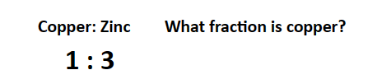  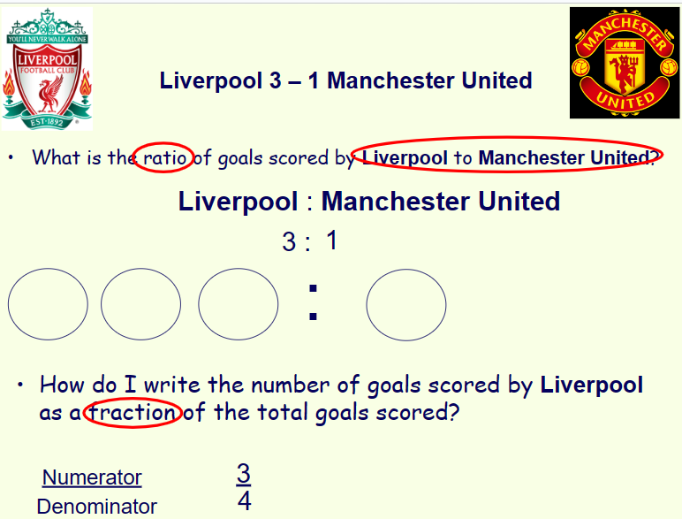 | Key vocabulary for this lesson & how it will be introduced?  Ratio, simplest form, part, proportion  Recall activity: 4 Qs (last lesson, last week, last month, last topic); Use questions from assessments (informal and formal) and QLA.  Suggested teaching activities, pedagogy and assessment to inform next steps:  Start with examples that explicitly ask questions about both ratio and proportion (fractions)  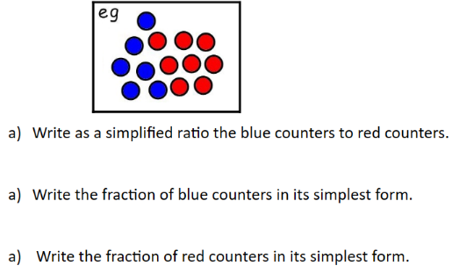  Give some questions where the ratio has more than 2 parts:  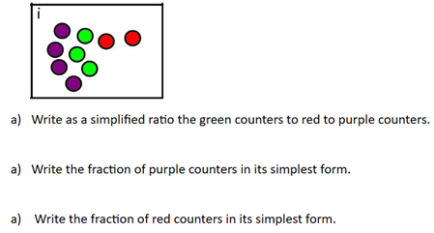  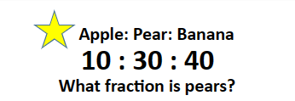
Addressing gaps  SEND learners have a Pupil Passport that informs strategies for learning bespoke to that student.  Staff must make sure they are familiar with the various strategies involved and embed these in their lessons.  Whenever a student does not understand revert to diagrams to help explain ratio questions. Encourage them to draw diagrams to help themselves answer questions. |  | Deepening knowledge  Application to problem questions  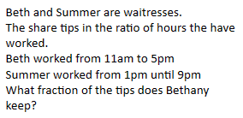

Week/ Lesson  Key Question? | Key knowledge components & Lesson Outcomes  What do students need to know & what should they be able to do? | Pedagogy & Assessment– How do we teach and assess this at Coal Clough Academy? Strategies to support students knowing more & remembering more  Suggested teaching activities & resources including ‘non-negotiables’ for delivery e.g. minimum of two assessment style questions per week, minimum of one practical per week…
Week 4/ Lesson 3 | What are the key knowledge components students must be taught this lesson?  - I know how ratio links to fractions  - I can simplify ratios and use ratios to solve problems.  What are the learning outcomes for this lesson?  - Problem solving ratio questions  - Dividing ratios  Key Questions:  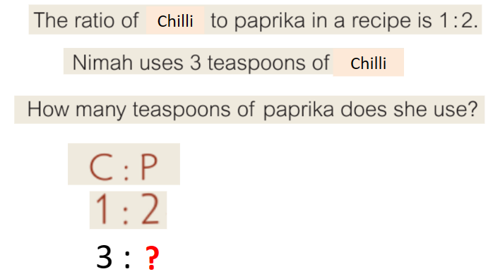 | Key vocabulary for this lesson & how it will be introduced?  Ratio, simplest form, part, proportion  Recall activity: 4 Qs (last lesson, last week, last month, last topic); Use questions from assessments (informal and formal) and QLA.  Suggested teaching activities, pedagogy and assessment to inform next steps:  Use both scaling up and dividing to answer questions  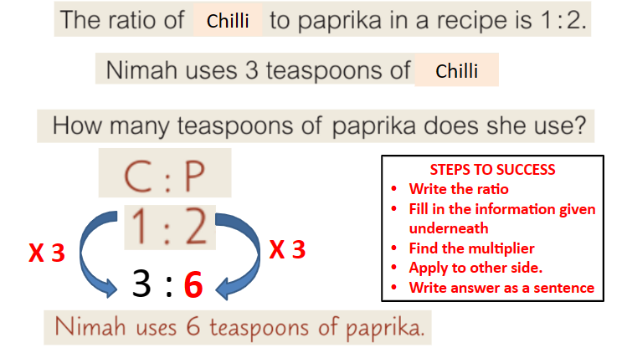  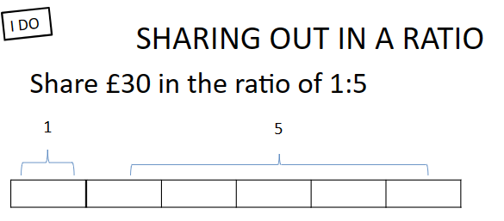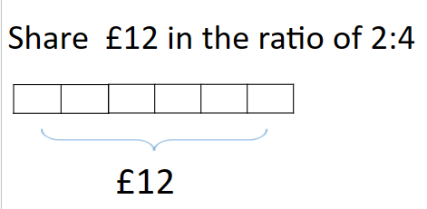  The bar model above is useful for giving students a visual to help them divide ratios.  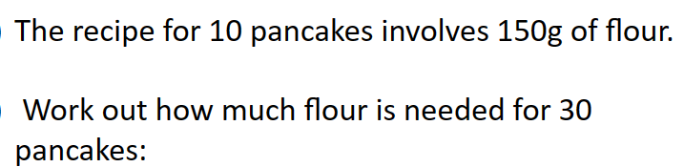  Try some questions where they have to work backwards and are given the quantity for one part and asked to calculate the number on the remaining part eg.,  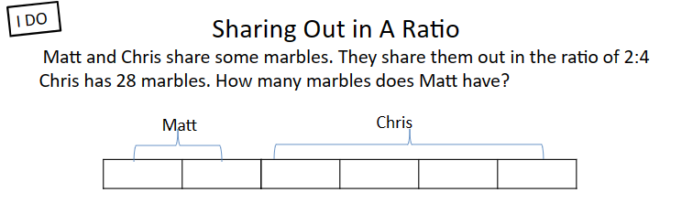
Addressing gaps  SEND learners have a Pupil Passport that informs strategies for learning bespoke to that student.  Staff must make sure they are familiar with the various strategies involved and embed these in their lessons.  Whenever a student doesn’t understand use diagrams – see bar model above. |  | Deepening knowledge  Use ratios with more than 2 parts  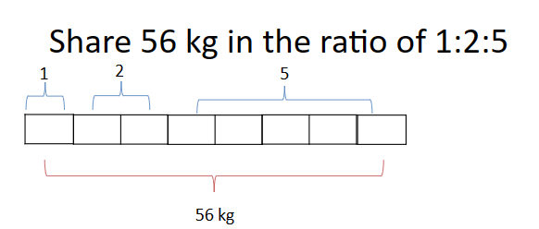

Week/ Lesson  Key Question? | Key knowledge components & Lesson Outcomes  What do students need to know & what should they be able to do? | Pedagogy & Assessment– How do we teach and assess this at Coal Clough Academy? Strategies to support students knowing more & remembering more  Suggested teaching activities & resources including ‘non-negotiables’ for delivery e.g. minimum of two assessment style questions per week, minimum of one practical per week…
Week 5/ Lesson 1 | What are the key knowledge components students must be taught this lesson?  - I know how to find a percentage change or an amount after a percentage change.  - I can find a percentage change or an amount after a percentage change  What are the learning outcomes for this lesson?  - Calculating % of a quantity (mental methods and calculator)  Key Questions:  What fraction is the same as 50%? 25%, 75%, 10%, 1%, 12.5%  If you need to find 80% what other easy percentages could you use to help you? (10% x 8 or other)  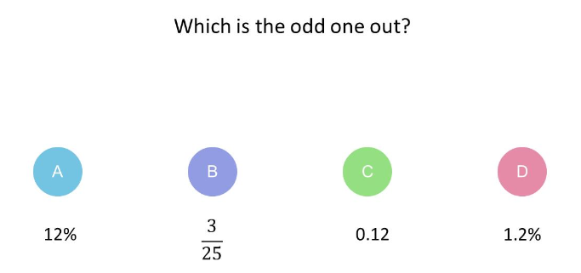 | Key vocabulary for this lesson & how it will be introduced?  percentage  Recall activity: 4 Qs (last lesson, last week, last month, last topic); Use questions from assessments (informal and formal) and QLA.  Suggested teaching activities, pedagogy and assessment to inform next steps:  Link this into fractions. Start with simple fraction to percentage conversions eg 50%, 25%, 75%, 10%  Teach students that they can convert percentages to a fraction and calculate using fractions instead.  Teach students that if they can find 50%, then they can find 75% by halving the answer to 50% and then adding both answers eg 75% = 50% + 25%  Get students calculating simple percentages using mental methods as above. Finally move onto teaching percentages of quantities using a calculator.
Addressing gaps  SEND learners have a Pupil Passport that informs strategies for learning bespoke to that student.  Staff must make sure they are familiar with the various strategies involved and embed these in their lessons. |  | Deepening knowledge  Give students problem solving questions eg  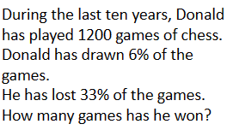

Week/ Lesson  Key Question? | Key knowledge components & Lesson Outcomes  What do students need to know & what should they be able to do? | Pedagogy & Assessment– How do we teach and assess this at Coal Clough Academy? Strategies to support students knowing more & remembering more  Suggested teaching activities & resources including ‘non-negotiables’ for delivery e.g. minimum of two assessment style questions per week, minimum of one practical per week…
Week 5/ Lesson 2 | What are the key knowledge components students must be taught this lesson?  - I know how to find a percentage change or an amount after a percentage change.  - I can find a percentage change or an amount after a percentage change  - I can find the original value of an item before a percentage change.  What are the learning outcomes for this lesson?  - % reductions eg sale prices (mental methods and calculator)  Key Questions:  See questions on multipliers under ‘suggested teaching activities’.  What multiplier would I use if I wanted to reduce a price by 20%? How do you know?  What about if I wanted to reduce a price by 2%?  If I got a 10% pay rise what multiplier would I multiply my current wage by?  If I got a 1% pay rise what multiplier would I multiply my current wage by?  My car has lost 20% of its value in the first year. I bought it for £12500 so what would it be worth now? How do you know? What calculation do I need to do on my calculator? | Key vocabulary for this lesson & how it will be introduced?  Percentage, multiplier, increase, decrease, reduction  Recall activity: 4 Qs (last lesson, last week, last month, last topic); Use questions from assessments (informal and formal) and QLA.  Suggested teaching activities, pedagogy and assessment to inform next steps:  Start with revision of multipliers  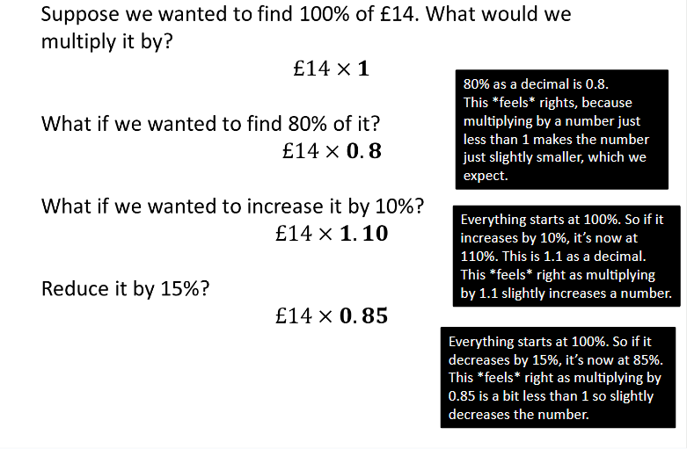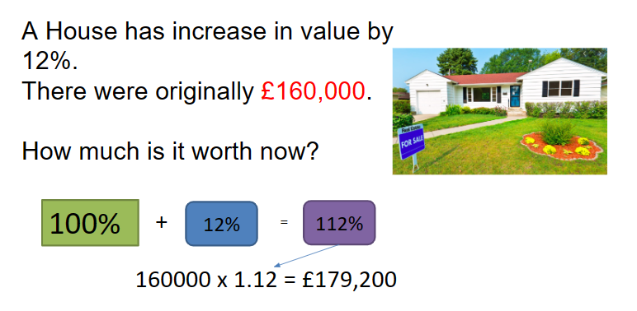  Then for the remainder of this lesson focus on percentage decreases, in particular, sale prices  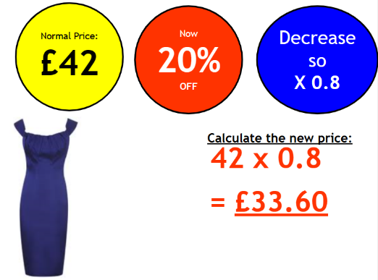
Addressing gaps  SEND learners have a Pupil Passport that informs strategies for learning bespoke to that student.  Staff must make sure they are familiar with the various strategies involved and embed these in their lessons.  Students often multiply by 1.3 when they want to increase a quantity by 3% instead of 1.03. Give them lots of practice at this eg an increase of 30% is 1.3 and increase of 5% is 1.05. |  | Deepening knowledge  Use problem solving questions or multi-step questions

Week/ Lesson  Key Question? | Key knowledge components & Lesson Outcomes  What do students need to know & what should they be able to do? | Pedagogy & Assessment– How do we teach and assess this at Coal Clough Academy? Strategies to support students knowing more & remembering more  Suggested teaching activities & resources including ‘non-negotiables’ for delivery e.g. minimum of two assessment style questions per week, minimum of one practical per week…
Week 5/ Lesson 3 | What are the key knowledge components students must be taught this lesson?  - I know how to calculate simple interest.  - I can use simple interest.  - I can read a worded question and decide whether I am calculating a percentage increase or decrease.  What are the learning outcomes for this lesson?  - % increases – mental methods  - Calculator methods for % changes  Key Questions:  I have £3000 in a savings account and get 5% interest at the end of the year. How do I calculate how much interest I’ll get? How much will I have in my bank account at the end of the year?  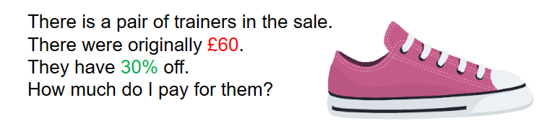 | Key vocabulary for this lesson & how it will be introduced?  Percentage, multiplier, increase, decrease, reduction  Recall activity: 4 Qs (last lesson, last week, last month, last topic); Use questions from assessments (informal and formal) and QLA.  Suggested teaching activities, pedagogy and assessment to inform next steps:  Use practical examples such as VAT  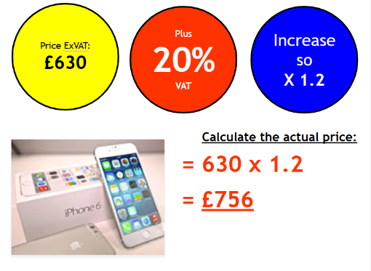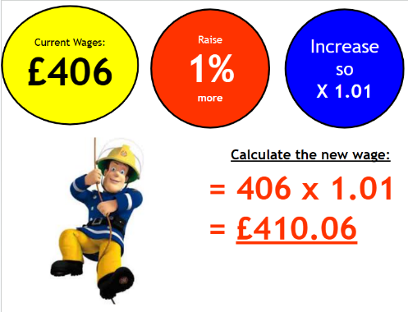
Addressing gaps  SEND learners have a Pupil Passport that informs strategies for learning bespoke to that student.  Staff must make sure they are familiar with the various strategies involved and embed these in their lessons. |  | Deepening knowledge  Give students problem solving questions  